CIRCUMSTANCE EVENT

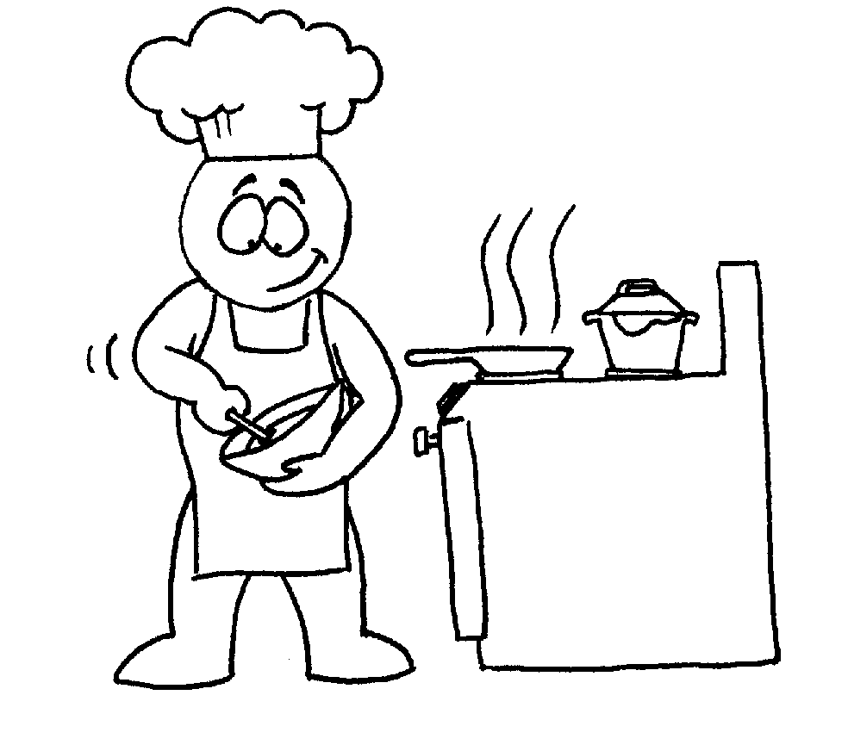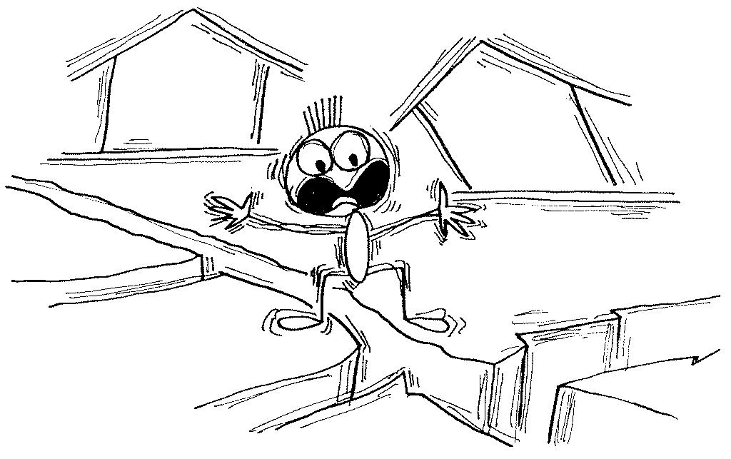
Past Progressive
Past Simple
I was cooking lunch when the earthquake began.

Which is the circumstance and which the event????

When the earthquake began, I was cooking lunch
The earthquake began while I was cooking lunch.
While I was cooking lunch, the earthquake began.

TIP:
WHEN + Past Simple
WHILE + Past Progressive
WHEN Past Simple + WHILE Past Progressive

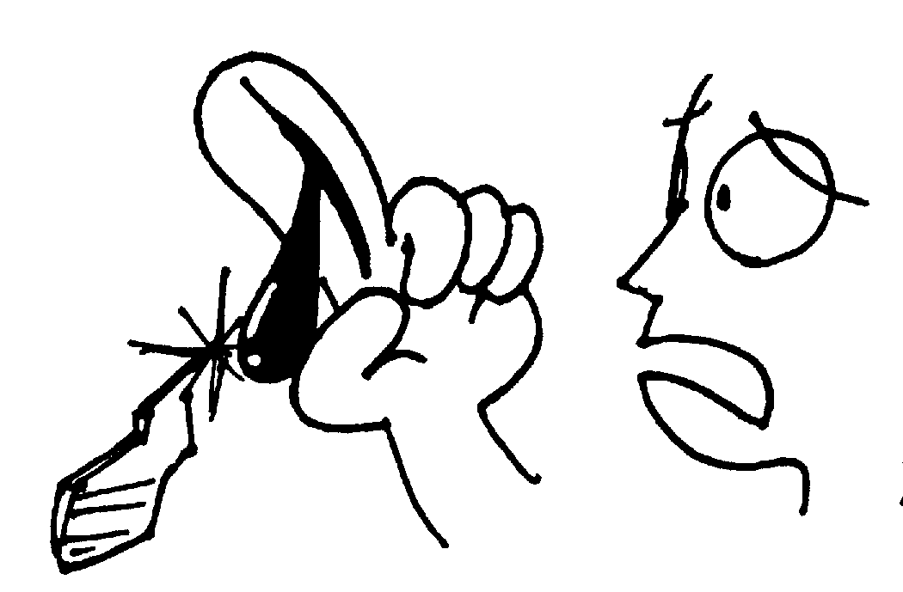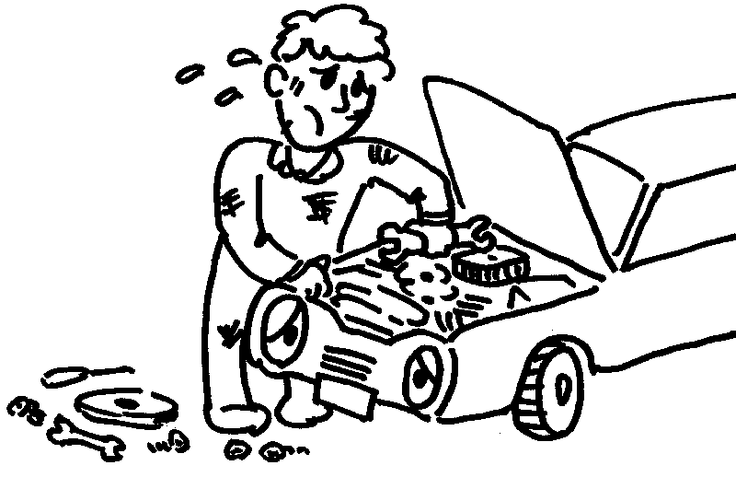

I _______my finger w_______ I _____________ my car



John _____________ the newspaper w_______ the telephone ____________

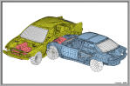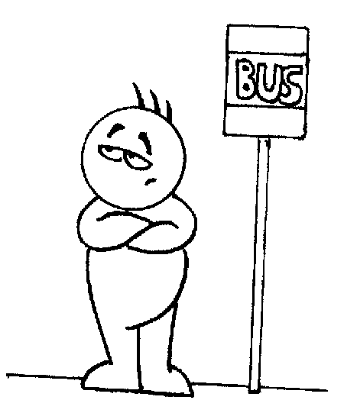

W _______Tom ____________ for the bus this morning, he _____________an accident .

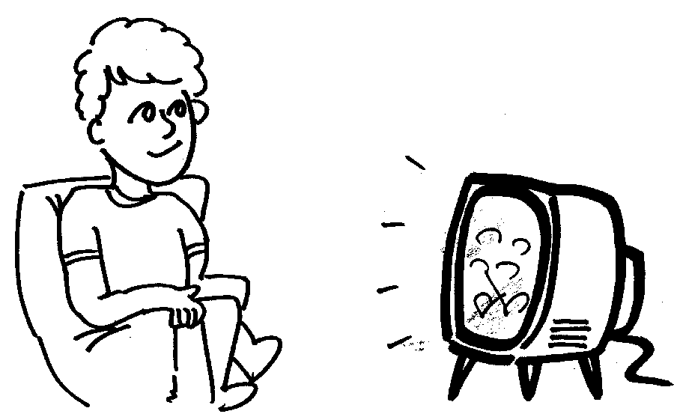 I _____________ when _______________
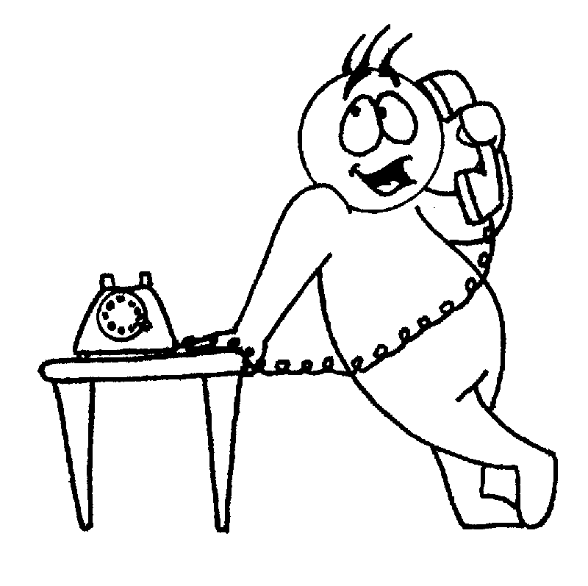 While Dick _________________________
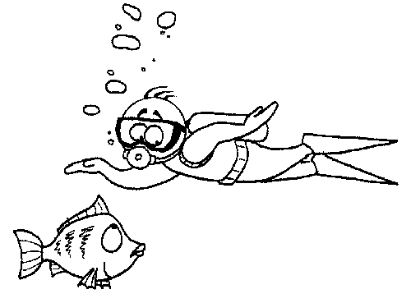 Don ______________ when he _________

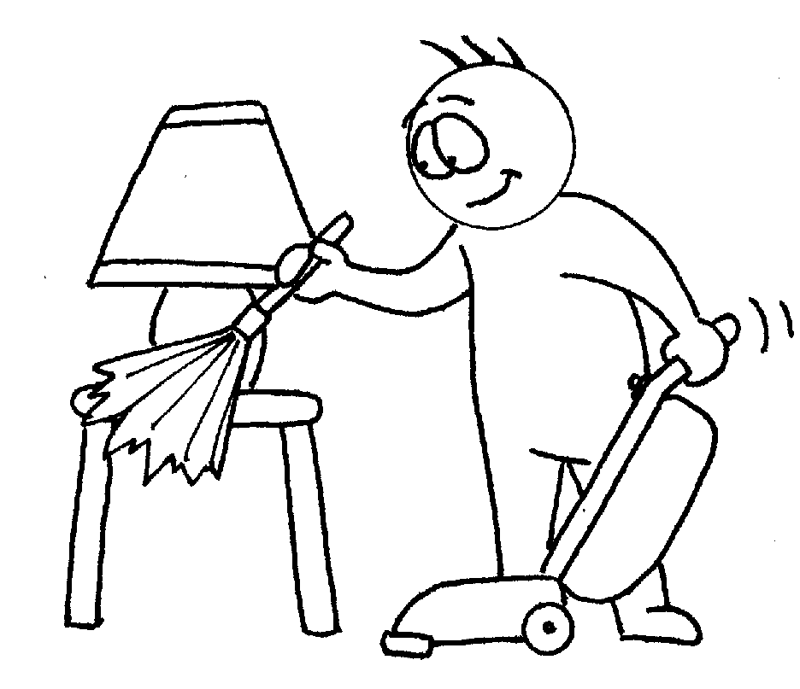 Donald ______________when __________

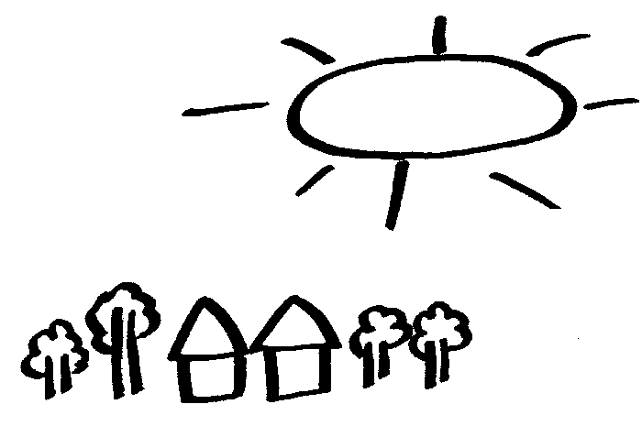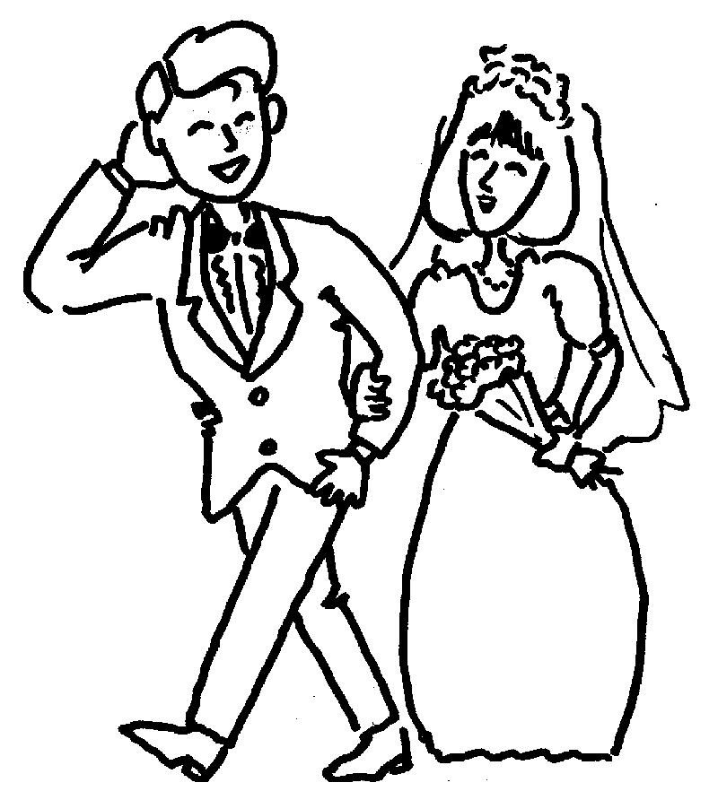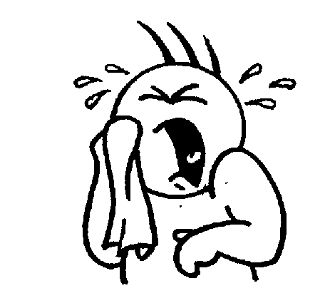

That day that John and Susan ________________ the sun _______________ and everybody __________ happy; except for poor Frank, he ______________ like a baby

. 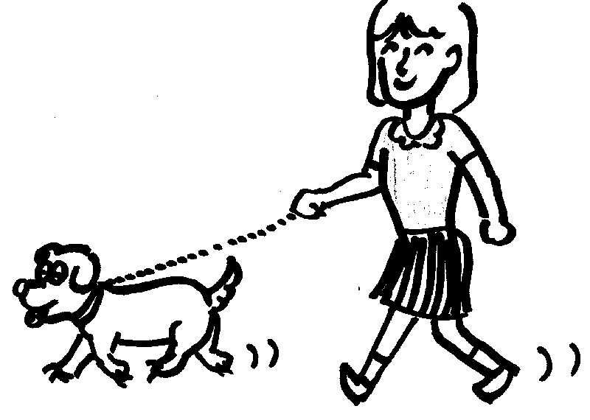 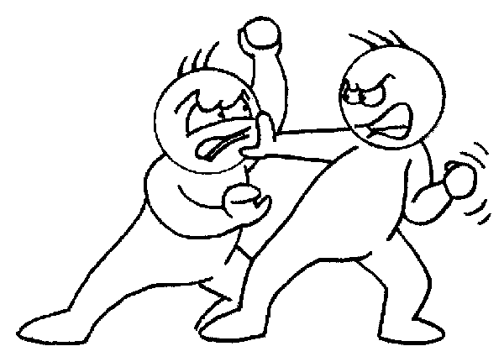

Nancy ______________________ the dog , when a fight ____________________ in the street.

